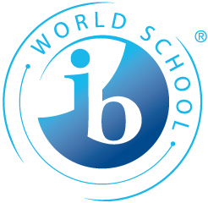

CAS Handbook for Troy High School
2012



IB Mission Statement

The International Baccalaureate aims to develop inquiring, knowledgeable and caring young people who help to create a better and more peaceful world through intercultural understanding and respect.

To this end the organization works with schools, governments and international organizations to develop challenging programmes of international education and rigorous assessment.

These programmes encourage students across the world to become active, compassionate and lifelong learners who understand that other people, with their differences, can also be right.

IB Learner Profile

The aim of all IB programmes is to develop internationally minded people who, recognizing their common humanity and shared guardianship of the planet help to create a better and more peaceful world. IB learners strive to be:

Inquirers They develop their natural curiosity. They acquire the skills necessary to conduct inquiry and research and show independence in learning. They actively enjoy learning and this love of learning will be sustained throughout their lives.

Knowledgeable They explore concepts, ideas and issues that have local and global significance. In so doing, they acquire in-depth knowledge and develop understanding across a broad and balanced range of disciplines.

Thinkers They exercise initiative in applying thinking skills critically and creatively to recognize and approach complex problems, and make reasoned, ethical decisions.

Communicators They understand and express ideas and information confidently and creatively in more than one language and in a variety of modes of communication. They work effectively and willingly in collaboration with others.

Principled They act with integrity and honesty, with a strong sense of fairness, justice and respect for the dignity of the individual, groups and communities. They take responsibility for their own actions and the consequences that accompany them.

Open-minded They understand and appreciate their own cultures and personal histories, and are open to the perspectives, values and traditions of other individuals and communities. They are accustomed to seeking and evaluating a range of points of view, and are willing to grow from the experience.

Caring They show empathy, compassion and respect towards the needs and feelings of others. They have a personal commitment to service, and act to make a positive difference to the lives of others and to the environment.

Risk-takers They approach unfamiliar situations and uncertainty with courage and forethought, and have the independence of spirit to explore new roles, ideas and strategies. They are brave and articulate in defending their beliefs.

Balanced They understand the importance of intellectual, physical and emotional balance to achieve personal well-being for themselves and others.

Reflective They give thoughtful consideration to their own learning and experience. They are able to assess and understand their strengths and limitations in order to support their learning and personal development.

WHAT’S THE POINT OF CREATIVITY, ACTION AND SERVICE?
Before we get started, let’s talk about why you have to do Creativity, Action and Service (CAS). You’re probably thinking: why are they giving us more to do? Don’t we have enough already? Leave me alone! Well I’m going to attempt to explain “the point” of Creativity, Action and Service, why it’s important and how it’s going to help you grow.
In the Diploma Programme a large part of your time will be devoted to the courses that you’ve selected from each group of the hexagon. What you learn in those courses is determined mainly by the International Baccalaureate (IB) with your teacher providing a little twist. You have some choices in your course selection however you have very little choice in what you learn in each of those courses. Don’t get me wrong, what you’re going to learn in those courses is going to be wonderful and new but CAS provides a rare opportunity. In CAS, you get to choose what you’re going to discover about yourself and the world around you. CAS is your chance to take charge of what you learn. You plan your CAS.
CAS is also different from your other IB courses in that CAS is an opportunity for experiential learning. It involves learning by experiencing which differs in many ways to learning in a classroom. Many high school students education is dominated solely by classroom learning but this is not the case for you. You have the opportunity to challenge yourself and learn in a completely different way than you would in the classroom.
Finally, CAS provides an opportunity for you to give back to and learn about your local or global community by getting involved. You have the opportunity to give your time and skills to beneﬁt other people who may need help or are less fortunate than us.
Everybody can be great, because anybody can serve -Martin Luther King Jr.
My advice is to approach CAS with an open and creative mind. Take a few minutes to think how you want to approach your CAS programme, what activities would challenge you and most importantly, think about what you would enjoy. CAS provides an opportunity for you to plan, observe and reﬂect but also have some fun.
As your CAS coordinator, I’m not only here to assess that you have evidence for the eight learning outcomes, I’m here to help. I want to see you challenge yourself and grow while having fun and feeling good about the activities that you’ve been involved in. Therefore, remember that my door is always open to help you at any stage of your CAS experience with your struggles and to celebrate your successes.
You must be the change you wish to see in the world - Mahatama Ghandi

What is CAS?

CAS is an integral component of the IB diploma program, CAS gives you, the student, a chance to extend yourself beyond the formal curriculum of study and apply knowledge in ways that will benefit both you and the community. It is a program that gives you a chance to contribute to your community - local, national and global.

CAS activities will most occur outside the walls of a classroom. An important aspect of the CAS experience is the emphasis on activities that are new to student. The emphasis is on learning by doing real tasks that have real consequences and then reflecting on these experiences over time.

There are three parts of CAS program – Creativity, Action and Service.

Creativity should be interpreted as imaginatively as possible to cover a wide range of arts and other activities outside the normal curriculum, which include creative thinking in the design and carrying out of service projects. Students are to be engaged in group activities and new roles whenever possible. Individual commitment in learning an art form is allowed -- that is, where goals are set and the student reflects on progress.

Action can include participation in expeditions, individual or team sports, and physical activities outside the normal curriculum. It also includes physical activity involved in carrying out creative and service projects. Action may involve participation in sports or other activities requiring physical exertion -- such as expeditions and camping trips. Group activities are strongly encouraged, but individual activities are also acceptable.

Service means contributing to the local, national, or worldwide community in an effort to make life better for others, especially those who are disadvantaged. This service neither seeks, nor accepts payment. Service projects are often the most transforming element of the Diploma Program for the individual student. Service involves interaction, such as the building of links with individuals or groups in the community. Service activities should not only involve doing for others, but also doing with others, and developing a real commitment to the project.

Students are encouraged to seek activities that combine different aspects of CAS.

CAS enables you to enhance your personal and interpersonal development through experiential learning. At the same time, it provides an important counterbalance to the academic pressures of the rest of the Diploma Programme. A good CAS programme should be both challenging and enjoyable, a personal journey of self-discovery. Each of you will have a different starting point, and therefore different goals and needs but ideally you will all have experiences that are profound and life-changing.

CAS involves:

- Real, purposeful activities, with significant outcomes
- Personal challenges – the tasks must extend you and be achievable in scope
- Thoughtful consideration, such as planning, reviewing your progress and reporting
- Reflection on outcomes and personal learning

An activity must meet all four of these criteria to be considered to be a CAS activity.

What is not CAS?

CAS is not a points-scoring exercise. It should be an interesting variety of activities that you find intrinsically worthwhile and rewarding, and which is mutually beneficial to you and to your community. Generally, CAS is not taking place when you are in a passive rather than an active role. There should be interaction. If you are passive, nothing of real value, either for you or for other people, results from what you are doing, and no real reflection is possible.

Examples of activities, which at first sight would appear to be inappropriate, are listed below.
- Any class, activity or project that is already part of the Diploma Programme.
- An activity for personal reward, financial or benefit-in-kind.
- Simple, tedious and repetitive work.
- A passive pursuit, e.g. museum, theatre, exhibition, concert visits.
- Part of family or religious duty.
- Work experience that only benefits the student.
- Fundraising with no clearly defined end in sight.
- An activity where there is no responsible adult on site to evaluate your performance.
- Activities that cause division amongst different groups in the community.
- Working in an old people’s or children’s home when you have no idea of how the home operates or are just making sandwiches. (This example can be applied to many other activities purporting to be CAS)

Aims of CAS

The CAS programme aims to develop students who are:

- Reflective thinkers. You should gain a better understanding of your strengths and limitations, identify goals and devise strategies for personal growth.

- Willing to accept new challenges and new roles.

- Aware of themselves as members of communities with responsibilities towards each other and the environment.

- Active participants in sustained, collaborative projects.

- Balanced. You should enjoy and find significance in a range of activities involving intellectual, physical, creative and emotional experiences.

Objectives of CAS

Having completed the CAS requirement, candidates should be able to demonstrate:

- Self confidence and modesty
- Attitudes and values which respect human dignity and which transcend barriers of race, class, religion, gender and politics
- An awareness of humanitarian and environmental issues and the development of an ethical position on them from a local, national and international perspective
- A sense of responsibility towards all members of the local, national and global communities and a commitment to be of value to those communities
- Personal qualities of curiosity, honesty and self-criticism
- An ability to reflect on and learn from experiences
- A spirit of discovery, commitment, initiative, determination and perseverance
- The ability to meet challenges and an awareness of personal limitations
- Practical skills which can be used in the service of others and in a future career.

Remember that the most meaningful CAS experience comes from spending time with others to build relationships and develop the self-worth of both server and served.

CAS PHILOSOPHY

- Counterbalance to academic absorption
- Education of the whole person
- Education beyond the classroom
- Development of attitudes and values which transcend race, religion, gender, and politics
- Promotion of international understanding
- Encouragement of new skill and interests
- Encouragement of a sense of responsibility to all
- Development of a spirit of discovery and self-reliance
- Challenge to the student
- Establishment of links with local, national and international communities
- Service to the community as a complement to intellectual development in the academic curriculum
- Promotion of more informed and understanding attitudes
- Development of awareness, concerns for and ability to work with others
- Sharing energies and talents

CAS Learning Outcomesbg

Learning outcomes are differentiated from assessment objectives because they are not rated on a scale. The completion decision for the school in relation to each student is, simply, “Have these outcomes been achieved?”

As a result of their CAS experience as a whole, including their reflections, there should be evidence that students have:

1. Increased their awareness of their own strengths and areas for growth
They are able to see themselves as individuals with various skills and abilities, some more developed than others, and understand that they can make choices about how they wish to move forward.

2. Undertaken new challenges
A new challenge may be an unfamiliar activity, or an extension to an existing one.

3. Planned and initiated activities
Planning and initiation will often be in collaboration with others. It can be shown in activities that are part of larger projects, for example, ongoing school activities in the local community, as well as in small student-led activities.

4. Worked collaboratively with others
Collaboration can be shown in many different activities, such as team sports, playing music in a band, or helping in a kindergarten. At least one project, involving collaboration and the integration of at least two of creativity, action and service, is required.

5. Shown perseverance and commitment in their activities
At a minimum, this implies attending regularly and accepting a share of the responsibility for dealing with problems that arise in the course of activities.

6. Engaged with issues of global importance
Students may be involved in international projects but there are many global issues that can be acted upon locally or nationally (for example, environmental concerns, caring for the elderly).

7. Considered the ethical implications of their actions
Ethical decisions arise in almost any CAS activity (for example, on the sports field, in musical composition, in relationships with others involved in service activities). Evidence of thinking about ethical issues can be shown in various ways, including journal entries and conversations with CAS advisers.

8. Developed new skills
As with new challenges, new skills may be shown in activities that the student has not previously undertaken, or in increased expertise in an established area.
Time Required for CAS

This focus on learning outcomes emphasizes that it is the quality of a CAS activity (its contribution to the student’s development) that is of most importance. The guidelines for the minimum amount of CAS activity is approximately the equivalent of half a day per school week (three or four hours per week), or approximately 150 hours in total, spread across 18 months of the Diploma Program. Time should be spent with a reasonable balance between creativity, action and service. “Hour counting”, however is not happening. Its emphasis should be on quality and less on quantity. Please remember that CAS activities should be meaningful and lead to reflection and self-development.

Your responsibilities

Your personal CAS programme should genuinely engage you and you should feel that you “own” it. It should be built on activities that are meaningful to you and to others. With the guidance of the school, you are given the opportunity to choose your own activities and to initiate new ones as appropriate.

You are required to:

- Self-review at the beginning of your CAS experience and to set personal goals for what you hope to achieve through your CAS programme.

- Plan, do and reflect. That is, plan your activities, carry them out and reflect on what you have learned.

- Undertake at least one interim review and a final review with a CAS adviser.

- Take part in a range of activities, including at least one project. You should have initiated some of these activities yourself.

- Keep a record of your activities and achievements, including a list of the principal activities that you have undertaken.

- Show evidence of achievement in the eight CAS learning outcomes.

The responsibilities of the school towards you

The school should:

- Help you identify your personal and social goals for CAS

- Monitor the range and balance of activities that you are undertaking

- Develop your powers of reflection

- Support you in your consideration of ethical concerns

- Read and respond to your diary/journal

- Help you to make connections (for example, between a CAS activity and a school subject, or between a local activity and a global concern).
Procedure for each activity

Think carefully about how the activity fits into your overall CAS programme.

Submit the activity proposal form.

Answer the guiding questions and send these to the CAS adviser. These will help you decide if the activity really is a CAS activity.

Check with your CAS adviser that the activity has been approved.

Carry out the activity.

Reflect continuously on the activity and document your reflection. You should reflect on each activity before you begin it, while you are carrying it out, and after completing it.

Documentation

It is important to document your ongoing activities and reflections.

This documentation can take many forms. Among these are a written journal and various ICT media.

Your documentation should provide evidence for:
- Your initial goals and plans for your CAS programme
- The CAS activities that you have undertaken
- Your plans for each activity or project
- Your reflections on each activity (before, during and afterwards)
- Which learning goals have been achieved and how

For each activity, you should also provide short report from your activity supervisor.

From your documentation, it should be possible for the reader to tell what happened, why it happened, how it happened, what its value was and what you learned from it.

Together with your CAS adviser, you will fill in:
- A CAS progress form
- A CAS individual student completion form

Evaluation

To meet the CAS requirement, you must fulfil each of the requirements listed in the section, “Your responsibilities”.

Meetings with CAS Coordinator/Advisor

I will be having one-on-one meetings with every Diploma student in October, January and May of your first year. In May of your first year I will be collecting CAS Journals and looking at CAS weblogs to see where each student is at. In May, you will also submit any completed Guided Questions for Proposed Activity, Activity Proposal Forms with supervisor signature, and record of activity

In your second year, we will meet in September and January to discuss your progress and in February I will be collecting CAS journals and looking at CAS weblogs for the final time. In February you will also submit all your Activity Proposal Forms

Using your CAS journals or CAS weblogs, Activity Proposal Forms, Report by Activity Supervisor, Record of Activity and CAS Review Report will determine whether you have achieved all the learning outcomes that IBO has put forth for CAS.

Copy letters and forms as needed for each CAS activity.

Meeting Schedule:
First year (grade 11)

October: Discuss planning: bring in completed Guided Questions for Proposed Activity and/or Activity Proposal Forms for activities you plan to do.
January: Discuss progress: submit any Report by Activity Supervisor forms that are completed
June: Discuss progress and submit necessary documents: to include journals

Second year (grade 12)

September: Discuss progress and return necessary documents
January (optional): Discuss progress
April: Submit all necessary document for assessment
Some Important Concepts

Some of the concepts that you will encounter in your CAS experience are:

- Experiential learning
- Reflecting

These are discussed in more detail below.

Experiential learning

This is at the core of CAS.

It involves more than just the activity itself. It also involves:

Planning

Identify your goals
Decide how you will reach these

Acting

Carry out real tasks
Gain concrete experience

Observing

Think about your feelings and your interactions with others
Analyse your perceptions

Reflecting

Identify your achievements, any outstanding issues, your personal strengths and your challenges
Evaluate your actions
Synthesize new understandings

Applying

Apply what you have learned to new situations
This process can also be viewed as a cycle shown on the next page for the more visual learner:

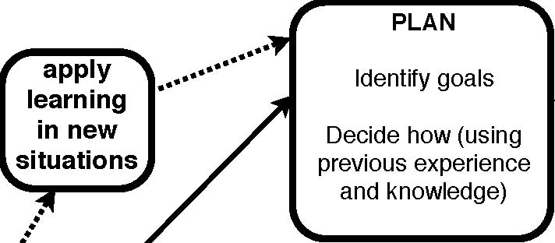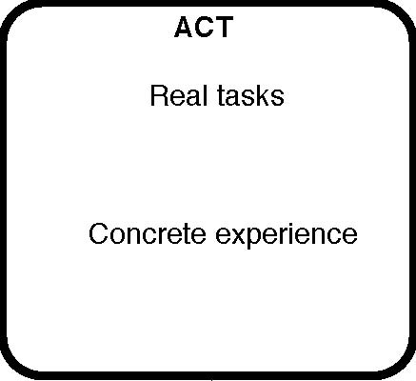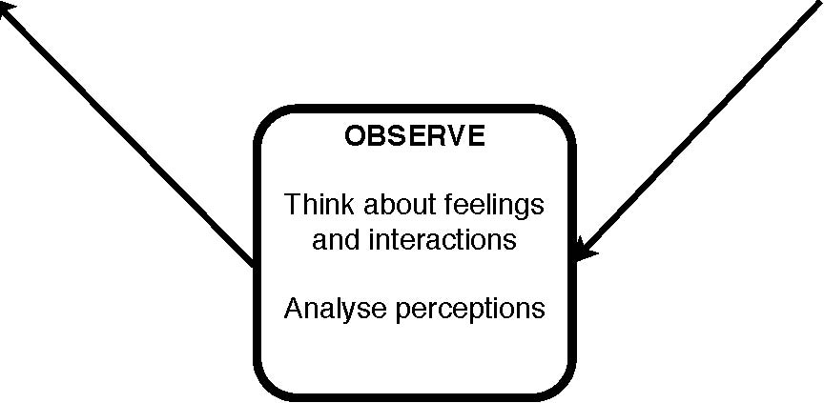Reflecting
EXPERIENTIAL LEARNING
The cycle of experiential learning gives you a basic idea of the approach you will be taking with each activity that will be contributing to your CAS experience.
The cycle of experiential learning



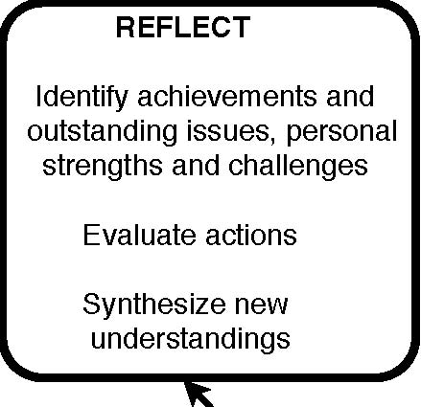

Reflection is a skill. Like any other skill, it is developed by practice.

The fundamental questions for any activity are:

- What did I plan to do?
- What did I do?
- What were the outcomes, for me, for the team I was working with, and for others?

The answers to these questions can be complex.

Your reflection can be:

- Public or private
- Individual or shared
- Objective or subjective

Most activities will involve a combination of these.

Reflection can be expressed in many forms. In the course of your CAS experience, you may find yourself reflecting:

- In private thoughts that you keep for yourself
- In writing, such as in your diary or journal, in the planning and evaluation forms, etc.
- In oral presentations to other students and to parents, such as in the CAS fair.
- In photo essays, DVDs, weblogs, or some other ICT medium.

Deeper questions

As you develop your skills of reflection, you may begin to consider some of the following:

- How did I feel?
- What did I perceive?
- What did the activity mean to me?
- What value did the activity have?
- What did I learn from this activity?
- How could this new insight be applied more widely?

Documentation and Forms

Guiding questions for the proposed activity

[These questions should be answered in a digital medium and sent to your CAS adviser]

Your answers to these questions will help you decide whether the activity qualifies as CAS. They should also help you better understand your goals and expectations for the activity. Discuss the questions with your CAS adviser, if you are unsure of how to answer any of them.

- Is it a real task that I am going to undertake? What is this task?

- What are my personal goals for this activity?

- Does it have real consequences for other people and for me? What are these?

- How will the task extend me as a person?

- Will be task be achievable?

- How will I plan the activity?

- How will I review my progress in the activity?

- How will I reflect on the outcome and on my personal learning?
Activity proposal form

[This form should be filled in on the computer, then printed and signed by the appropriate persons]

Student name: _________________________________________________

Activity title: _____________________________________________________

Activity area: __Creativity __ Action __Service

Projected hours : _____ weekly ______total

The supervisor

Name of the supervisor:

Position of the supervisor:

E-mail:

Telephone:

Mobile number:

I have read the letter to the supervisor and agreed to supervise the above student.

_____________________________ ____________________
Signature of supervisor Date

Parental approval (for students aged less than 18)

I agree to my child or ward being supervised by the above signatory for the designated activity.

_____________________________ ____________________
Signature of parent/guardian Date
Letter to parents/guardian

Dear Parent or Guardian

As a part of the International Baccalaureate (IB) diploma, students must complete a programme called CAS, which stands for Creativity, Action, Service.

The CAS programme aims to provide the student with challenges in three areas:

Creativity. This covers a wide range of creative activities, including the arts, and creative-thinking in carrying out projects.

Action. This includes sports and other physical activities outside the normal curriculum.

Service. This entails doing things for others and with others, in a relationship of mutual respect.

The students are expected to spend at least 50 hours in activities that involve each of these three areas, giving a total of 150 hours. They should undertake each task with clear goals and with a responsible adult supervisor. The students should not receive payment for these activities and they should not be assisting family members or relatives. The chosen activities should involve the active participation of the students. The students’ reflection on their activities is an essential part of the experience.

I hope that this explains the general outline of the CAS programme and some of what your child will be doing during the coming two years.

Should you have any enquires regarding the CAS programme, please contact me, the CAS coordinator.

Thank you for your support.

With regards,

CAS Coordinator
Letter to the activity supervisor

Dear Activity Supervisor

The International Baccalaureate (IB) diploma is a programme of education held at upper-secondary schools throughout the world. As a part of the IB diploma, students must complete a programme called CAS, which stands for Creativity, Action, Service.

The CAS programme aims to provide the student with challenges in three areas:

Creativity. This covers a wide range of creative activities, including the arts, and creative-thinking in carrying out projects.

Action. This includes sports and other physical activities outside the normal curriculum.

Service. This entails doing things for others and with others, in a relationship of mutual respect.

The students should undertake each task with clear goals and with a responsible adult supervisor. The students should not receive payment for these activities and they should not be assisting family members or relatives.

Your cooperation as an activity supervisor would be greatly appreciated. Your understanding, support and guidance are important for the overall success of the young person in the activity.

As a supervisor, you will be asked to evaluate the student’s performance. In particular, you will be asked to monitor the student’s attendance, provide guidance and support relating to the activity, alert the CAS coordinator of any problems, and report on the student’s performance.

Should you have any enquires regarding the CAS programme, please contact me, the CAS coordinator.

Thank you for your support.

With regards,

CAS Coordinator
Report by the activity supervisor

Name of student supervised:

Activity supervised:

Number of hours spent by the student on the activity:

Please comment on the student’s:

Punctuality

Reliability

Commitment

Please add any other comments that you feel would be useful.

Supervisor’s name: _____________________________________

Supervisor’s signature: __________________________________

Date: _____________________________
REcord of Activity
Student Name: _____________________________________________________
CAS Activity Name: __________________

Date | Activity Description | C/A/S | Hours | Supervisor’s Name | Supervisor’s Signature

SAMPLE CAS Journal Page

Title of project/Activity:

Individuals involved (teamwork required):

CAS Components involved (C, A, S):

Date or date range of project:

Total number of hours:

Principal activity or activities:

Location of project:

Supervisor’s name, title, and signature:

Learning outcome(s):
_____Increased awareness of strengths and areas for growth
_____Undertaken new challenges
_____Planned collaboratively with others
_____Shown perseverance and commitment
_____Engaged with issues of global importance
_____Considered the ethical implications of actions
_____Developed new skills

Reflection:

CAS Planning Guide (turn in to CAS Advisor fall of junior year)

Goals/Area of Focus: “Think Globally, Act Locally”

Activities/projects for CAS I plan do:

How will I satisfy CREATIVITY?

How will I satisfy ACTION?

How will I satisfy SERVICE?

 | Activity or Project Name | Supervisor’s Name  (will oversee and sign off on hours) | Planned Start Date | Planned Finish Date | Projected hours
1
2
3
4
5
6

CAS progress form
[To be filled in together with the CAS adviser]

Name of student:

Name of CAS adviser:

Event | Date | Signature | Comments
First consultation between CAS adviser and student | Fall Jr. Year
Student has declared an acceptable plan for CAS activities | Fall Jr. year
Second consultation between CAS adviser and student | Spring Jr. year
Student has submitted record of experiences for mid-term evaluation | Fall Sr. Year
Third consultation between CAS adviser and student | Spring Sr. Year (if necessary)
Student has submitted final reflective piece and record of experiences | April Sr. year

CAS completion form
[To be filled in together with the CAS adviser]

Name of student: ______________________________

There is evidence that the student has fulfilled each of the following learning outcomes.
Learning outcome | Achieved (x) | Nature and location of evidence (weblog/date, journal/page, etc)
1.Increased their awareness of their own strengths and areas for growth
2.Undertaken new challenges

3.Planned and initiated activities

4.Worked collaboratively with others

5.Shown perseverance and commitment in their activities

6.Engaged with issues of global importance

7.Considered the ethical implications of their actions

8.Developed new skills

______________________________ _______________________________
Name of CAS adviser Signature of CAS adviser Date

CAS Review Report
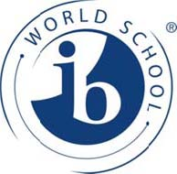
Date: ____________________________
Candidate Name: __________________________________________________ Candidate Number: _______________
In addition to your reflections on each CAS activity and completion of all learning outcomes, as you have logged them, you must explain how you achieved the following CAS requirements:
Requirement: Self-Initiated CAS Activities
List all CAS activities which have been self-initiated (not initiated by the CAS Coordinator, IB Coordinator, or other member of the school community):
Requirement: CAS Project
List tithe CAS activity that represents a “project” – a CAS project involves teamwork, integrates two or more aspects of creativity, action and service, and is of significant duration over time:
Requirement: Global Significance
List all CAS activities that show international--mindedness:

